LAB 10

Note: The programs in all questions should include struct statements.

1- Write a program that finds the difference between two given clocks in hour and minute unites.

Example:
Inputs: 14:10 14:25
Output: 15 minutes

2- Write a program that determines whether the object with given three edges is a triangle or not.

a+b>c a+c>b b+c>a
a-b<c a-c<b b-c<a

Examples:
Inputs: a=3 b=7 c=32  Output: It is not a triangle | Inputs: a=3 b=4 c=5  Output: It is a triangle

3- Write a program that takes two points (x1,y1) and (x2,y2) from the user and then prints the equation of the line
y = mx + c passing through the two points, where

the gradient 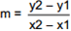 and the constant c = y1 – m * x1

Implement a structure that represents a point, say with x and y.
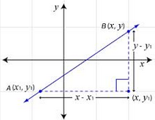

4- Write a program to implement a structure that represents the normal 3-vectors and cross producting.

Vector a (a₁, a₂, a₃)
Vector b (b₁, b₂, b₃)

Cross producting:
(a₁, a₂, a₃) cross (b₁, b₂, b₃) = (a₂ b₃ - a₃ b₂, a₃ b₁ - a₁ b₃, a₁ b₂ - a₂ b₁).

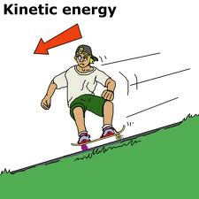
5- Write a program that takes the velocity (vx, vy, vz) and mass (m) values of a 3D particle from the user and finds kinetic energy.

Momentum (px, py, pz):
vx = px / mass
vy = py / mass
vz = pz / mass

kinetic energy = 1/2 m (vx² + vy² + vz²)

6- Write a program that creates an array of Doctors and allow user to insert a new doctor.

struct Address {  public text;  public string city;  } | struct Date {  public int day;  public int month;  public int year;  } | struct Doctor {  public string name;  public Address address;  public Date birthdate;  }
Example:
Input: Name = Derya
Address text = Davut cad. No:2
City = izmir
Birthdate (day) = 27
Birthdate (month) = 3
Birthdate (year) = 1988

